Wrong Position
The tower is placed in wrong position
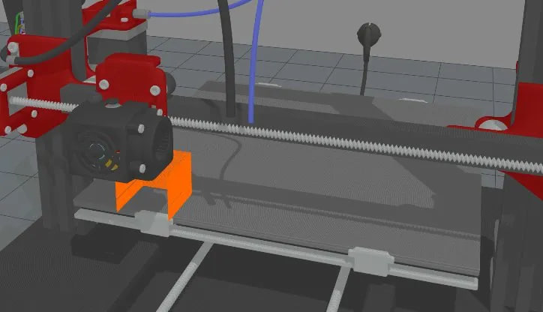
Other examples
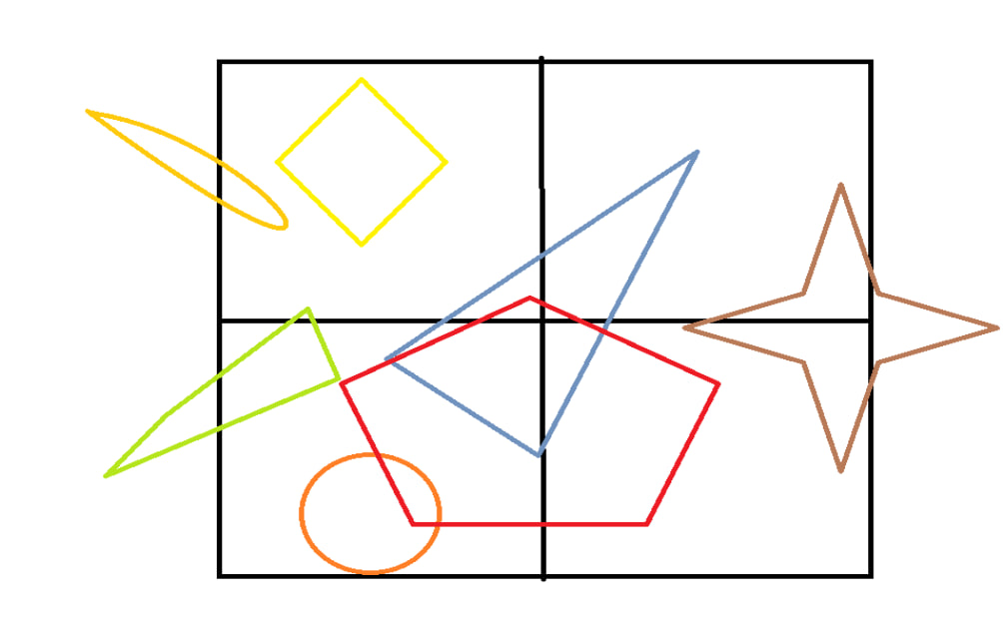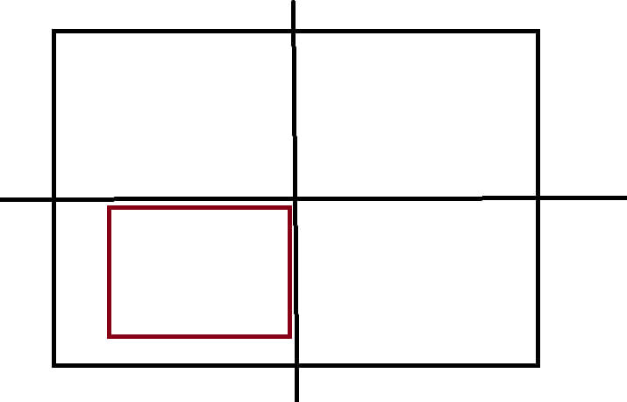
The placement of the printed model should be in center of the bed so :
- The center of the model in the center of the bed
- In code we have corner and center , when running code we use center, how
In G-code, coordinates can be referenced from either the corner or the center—it depends on how the machine’s origin (0,0) is set. G-code itself does not force one method.
Most CNC machines and many 3D printers use the front-left corner of the bed/workpiece as X0 Y0.
Example
G0 X0 Y0
➡ The tool moves to the front-left corner.
G1 X100 Y50
Move 100 mm right and 50 mm back from that corner.
Typical setup:
- X0 Y0 → front-left corner
- X increases → right
- Y increases → toward the back
So it has to adapt that we can know whether the G-code uses corner origin or center origin, but you usually determine it by checking the machine setup and the G-code values
Check the Machine Home Position via G28
Look at the Coordinates in the G-code
All values positive → usually corner origin.
Check the CAM / Slicer Settings
Check Work Coordinate Commands
G92 can redefine the current position as (0,0).

Maybe we need to update code to have Printer profile

Filament issues:
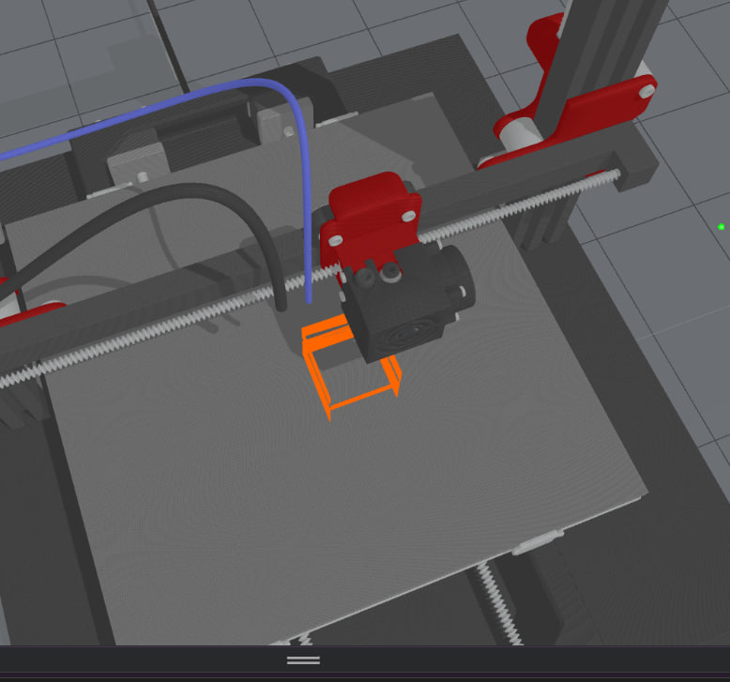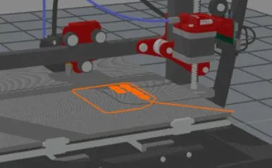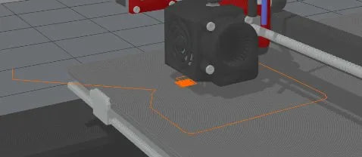
Extra unwanted filament , maybe because filament render prints the motion of nozzle not what g-code tells
Deformed filaments because of several factors such as :
- Speed of printing, layerHeight , maybe delay but I don’t think so

